**Jenkins Task-2**

**Task Description:**

Create a simple script file and push it to repo. Create a project in Jenkins connected to your GitHub repository. When a commit is made to your repo, automatically build must get triggered from Jenkins and the output must be shared to me via email.

Explanation:

1. In AWS, launch an EC2 instance.

Login to AWS console, In EC2 dashboard, click launch instance.

The following details is given.

Name : my-jenkins-server

AMI: Amazon Linux 2 AMI

Instance Type: t2.micro

Key Pair: New key pair is generated

Post launching instance, the security group can be modified by Adding a new rule to allow **Custom TCP (port 8080).**

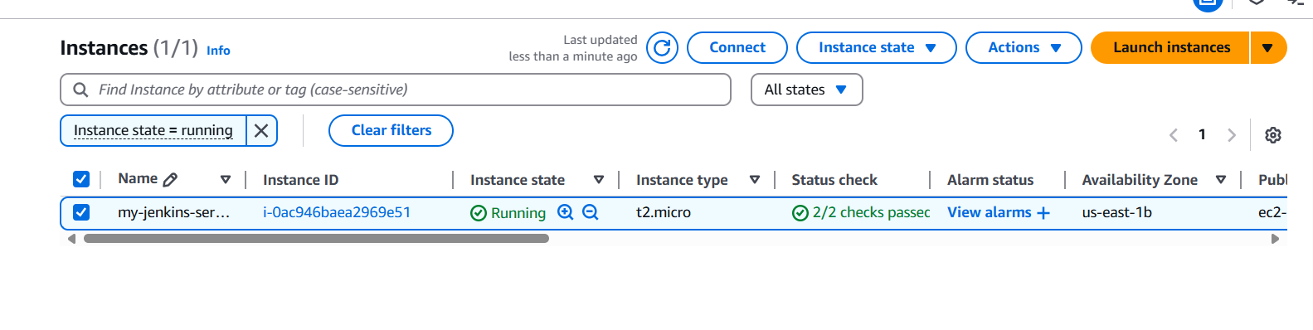

Connect using EC2 instance

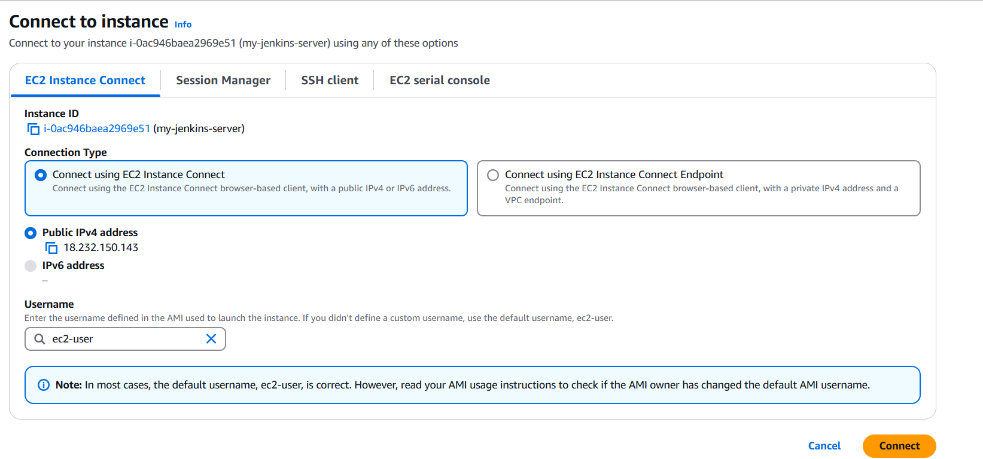

1. Once Ec2 is connected, Check the status of the jenkins

sudo systemctl status jenkins

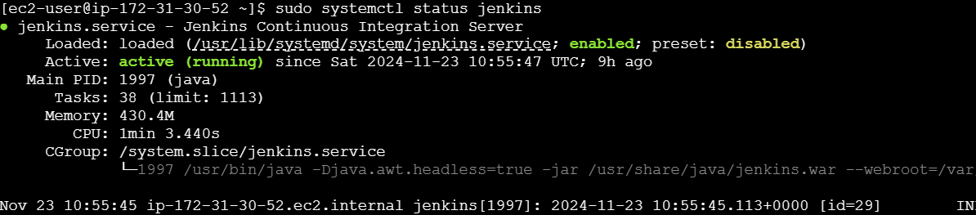

Access Jenkins: Open a browser and go to: http:// 18.232.150.143:8080

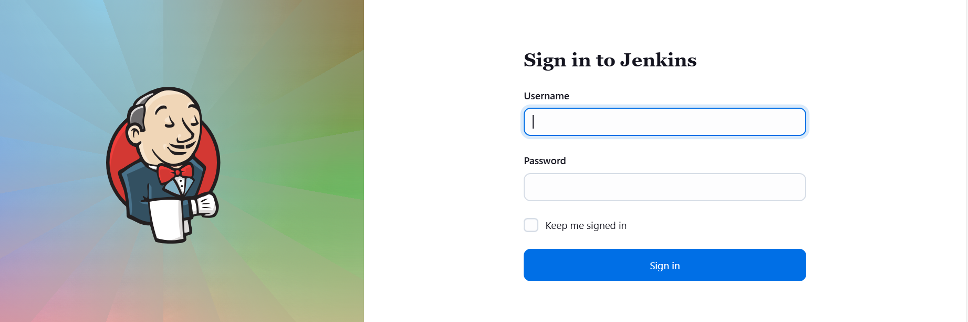

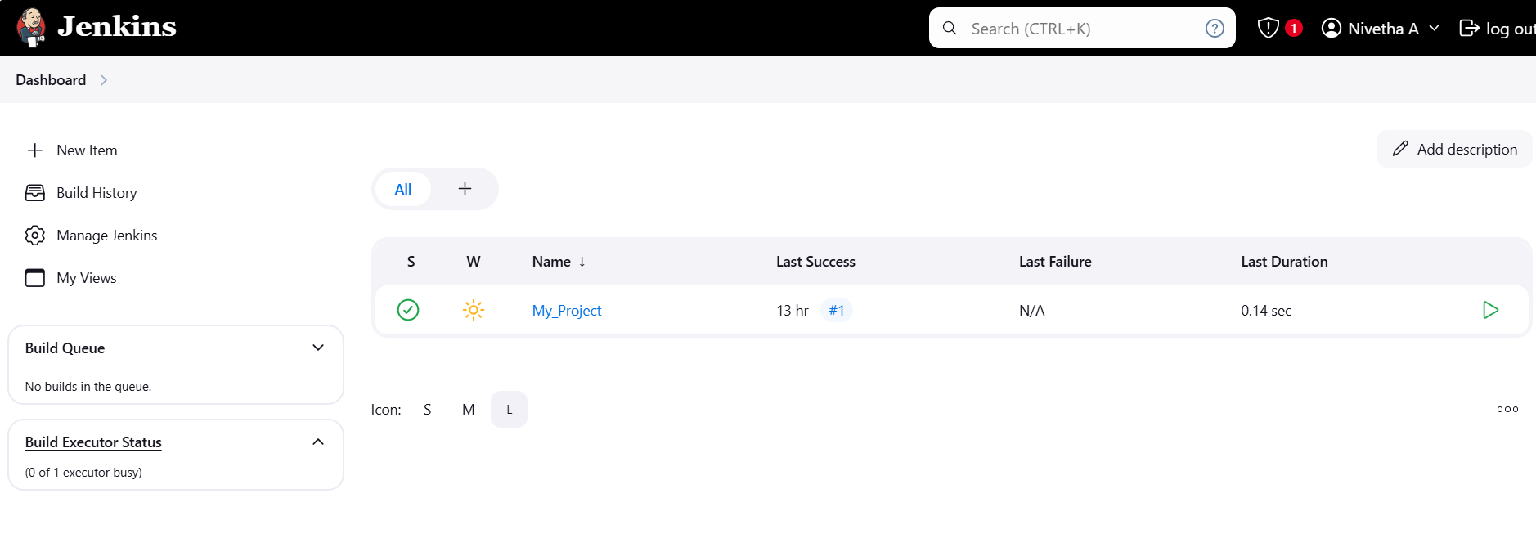

1. Create the new repository (Jenkins_repo) in the git hub account if required and copy the URL

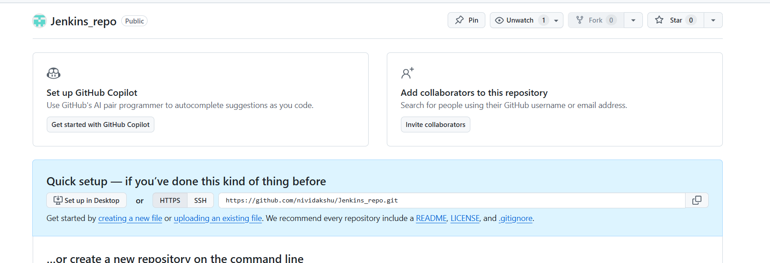

1. On your EC2 instance, ensure Git is installed

sudo yum update -y

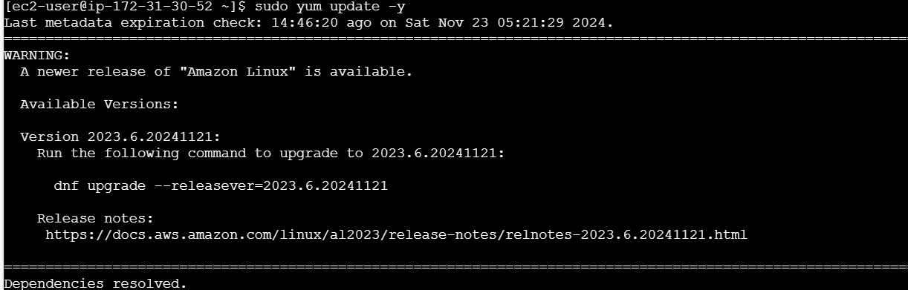

sudo yum install git -y

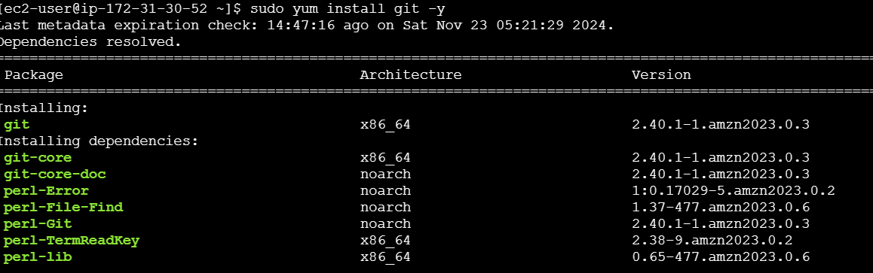

1. Create new directory and navigate to the directory

mkdir jenkins_project

cd jenkins_project

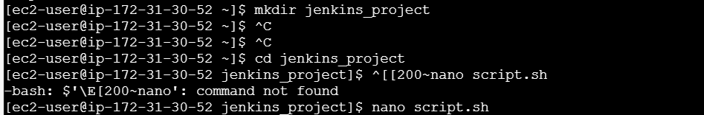

1. Create new file

nano script.sh

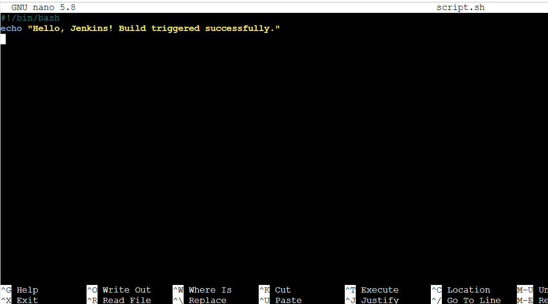

Set permissions : chmod +x script.sh

Initialize git repo : git init

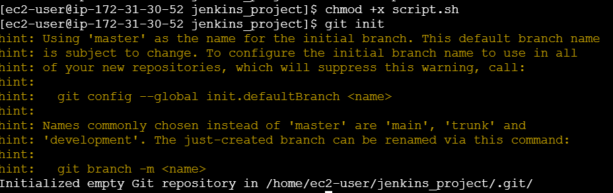

git add script.sh

git commit -m "Initial commit"

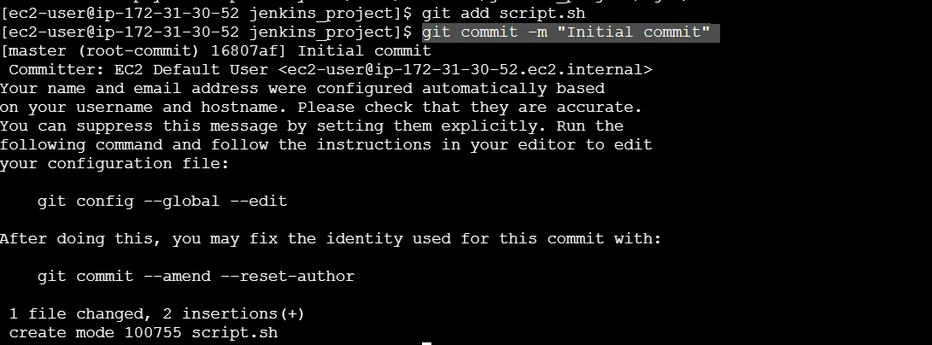

git remote add origin <https://github.com/nividakshu/Jenkins_repo.git>

git branch -M main

git push -u origin main

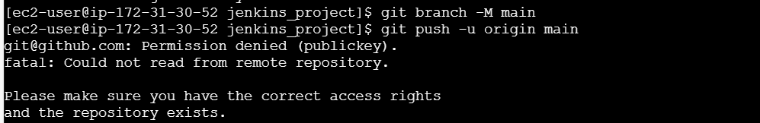

Since EC2 instance connect is used, the following steps is done for github ssh authentication

ssh-keygen -t ed25519 -C [nivethadhaksha@gmail.com](mailto:nivethadhaksha@gmail.com) and pressed enter to save in the default location

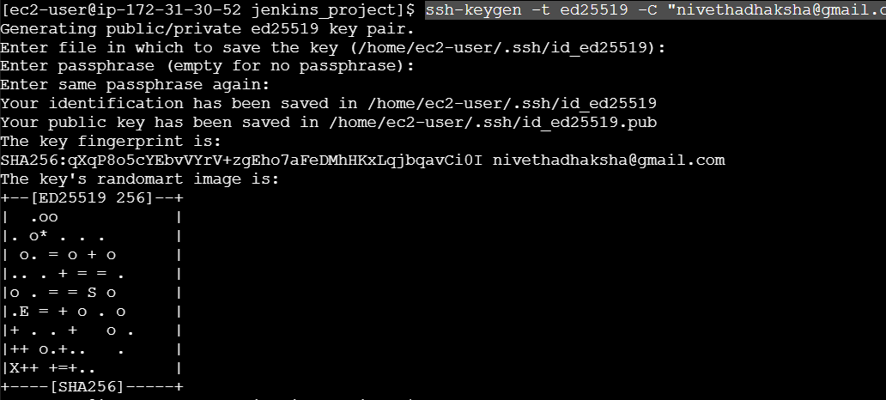

After key generation, check using ls ~/.ssh



To display the contents of key file use cat ~/.ssh/id_ed25519.pub and copy the output



1. In Github accout, navigate to below path

Settings > SSH and GPG keys > new ssh key > paste the copied output > name it as EC2 instance key> add ssh key.

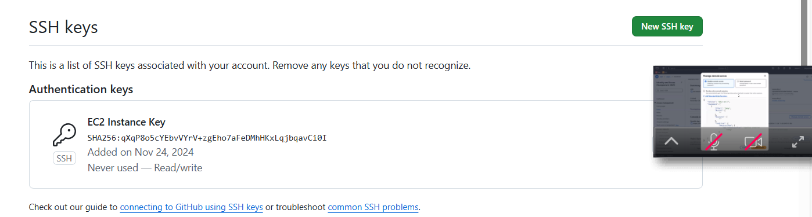

Add the private key to ssh agent using

eval "$(ssh-agent -s)"

ssh-add ~/.ssh/id_ed25519

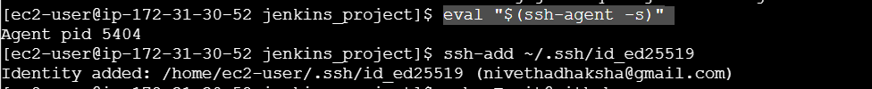

To test if the EC2 instance can connect to git hub via newly generated ssh key use

ssh -T [git@github.com](mailto:git@github.com)



Then, use the following commands,

git remote set-url origin [git@github.com:nividakshu/Jenkins_repo.git](mailto:git@github.com:nividakshu/Jenkins_repo.git)

git remote -v

git branch -M main

git push -u origin main

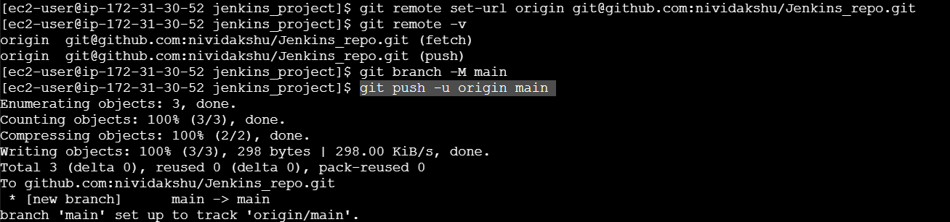

1. Go to Jenkins dashboard using http:// 54.234.64.193 :8080 and install or check for the beow mentioned plugin – Dashboard>manage Jenkins >plugins

Git Plugin

GitHub Integration Plugin

Email Extension Plugin

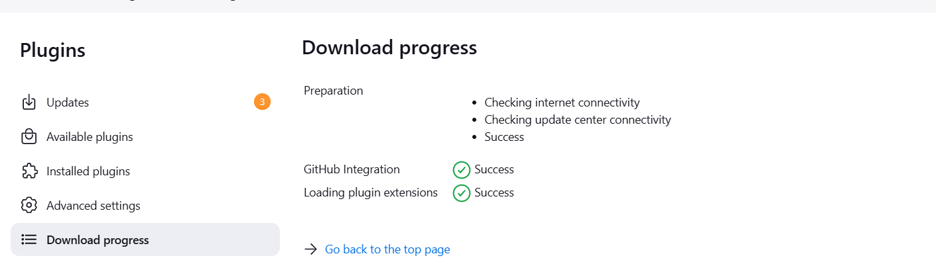

1. Go to dashboard > new item > freestyle project > Name : Github_project

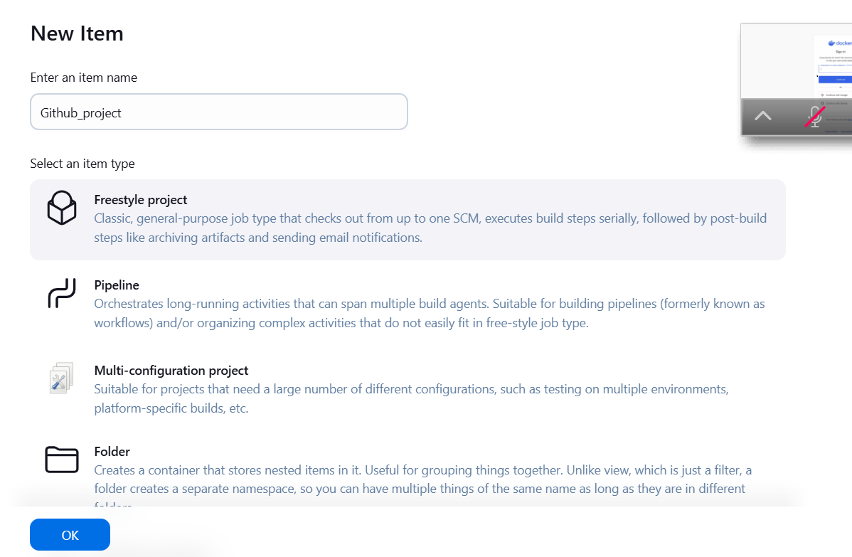

In the configuration page, select GIT under scm and paste the url

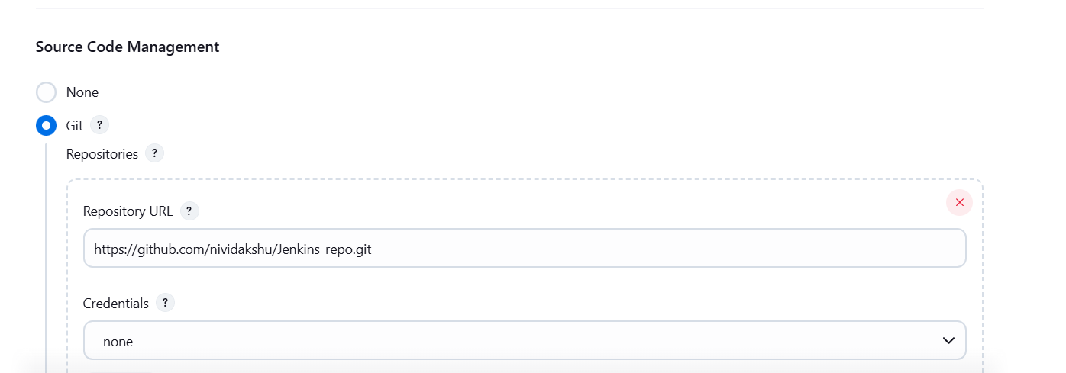

Under bulid Trigger, select github hook trigger

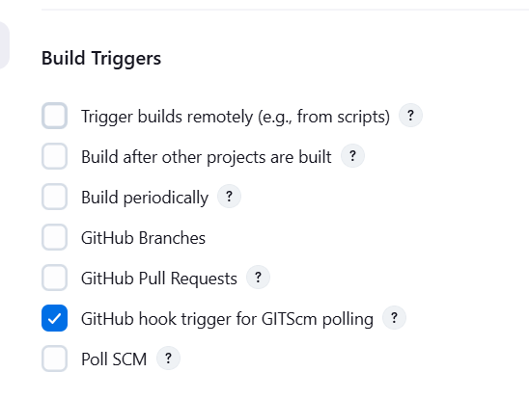

Under build steps, add shell script ./script.sh

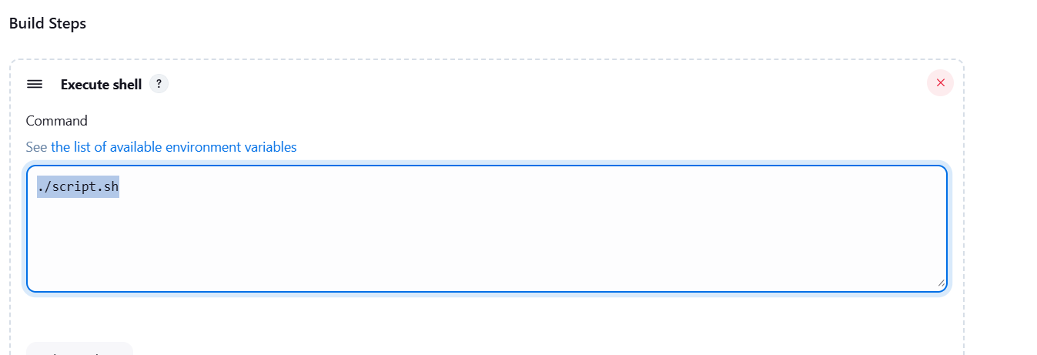

Under post build actions, select, editable email notifications and give the subject ,content, as required.

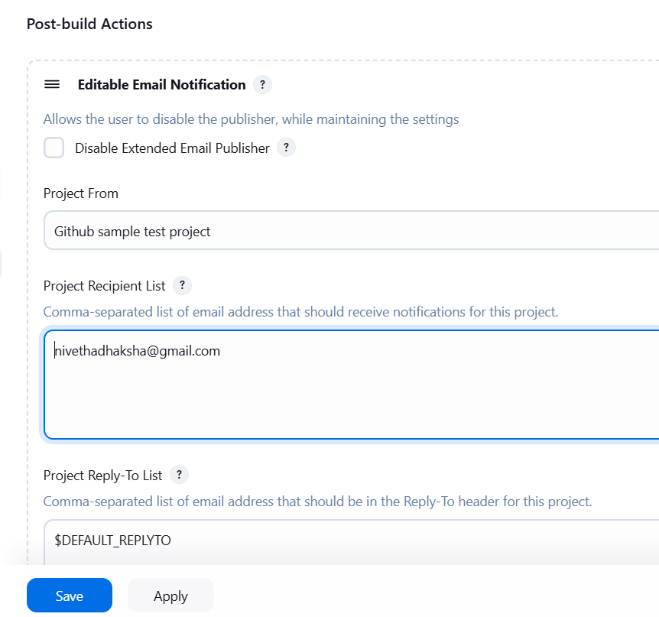 Go to github repo, navigate to settings > webhook> add a new webhook

enter the url :http://54.234.64.193:8080/github-webhook/

choose content type : json, select just the push event and click add webhook.

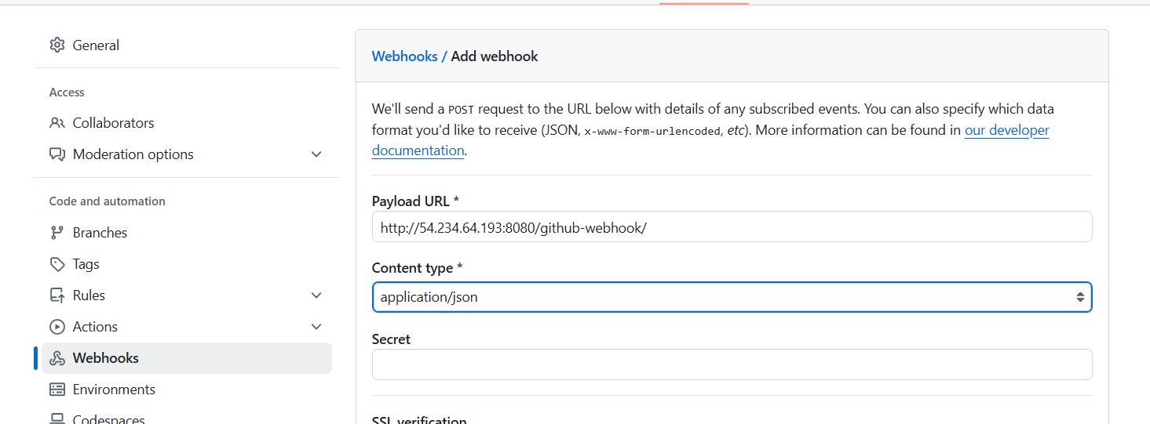

To test, edit the script.sh file

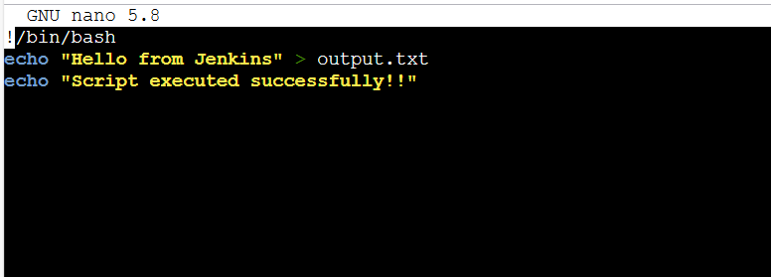

Commit and push the changes

git add script.sh

git commit -m "Updated script"

git push

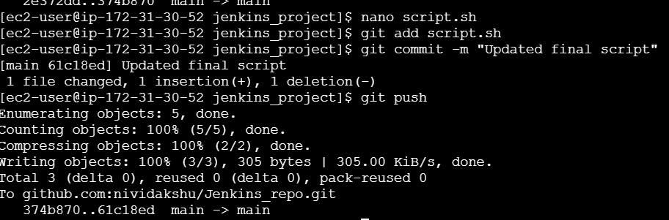

1. Verify Jenkins build

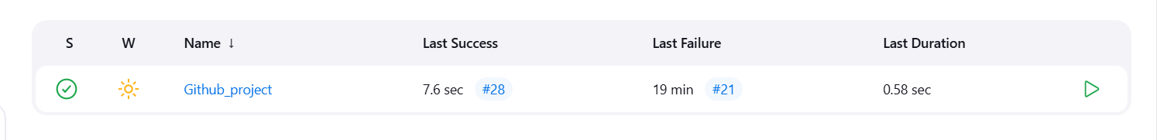

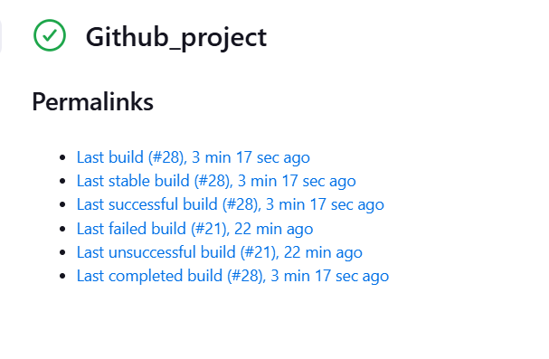

Mail Trigger:

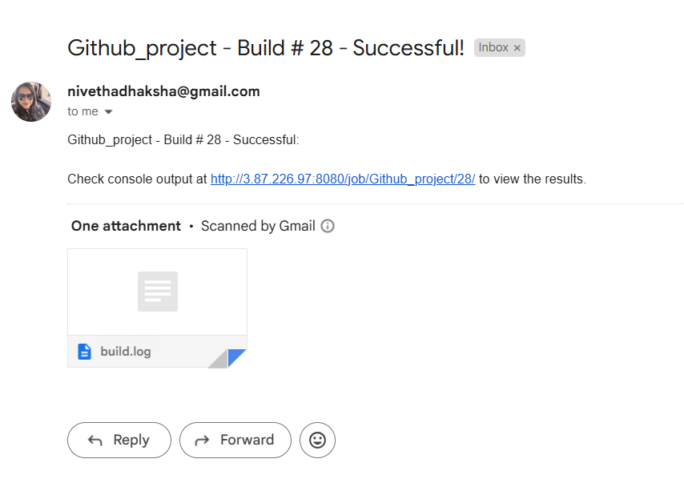

Console Output:

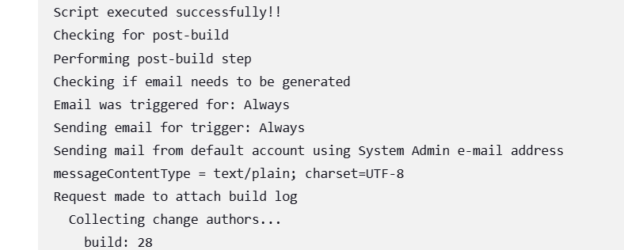 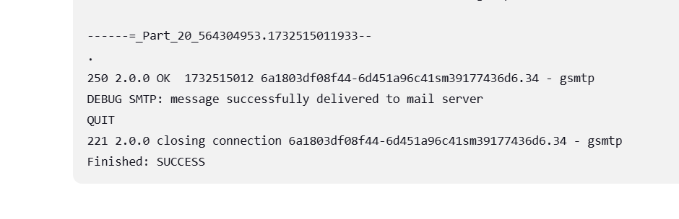 **Webhook delivery :**

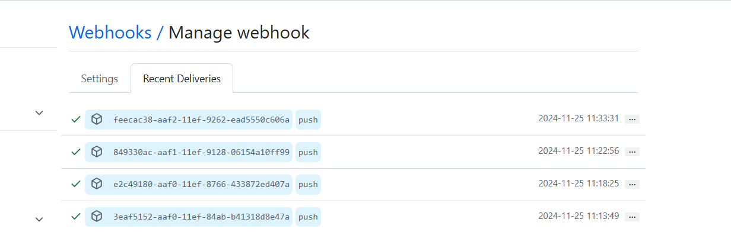

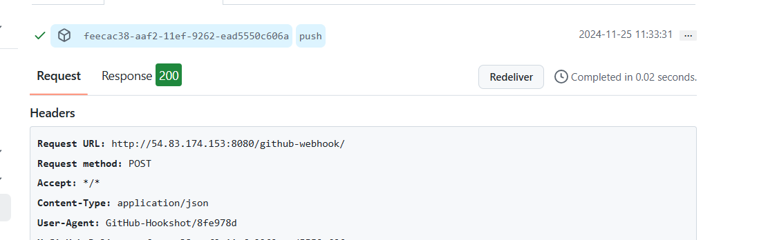

**Output:** whenever the push occurs, Jenkins build is automated and mail is triggered.